**Stage A - picture repainting**

An old picture of Chinese soldier - How can we repair this picture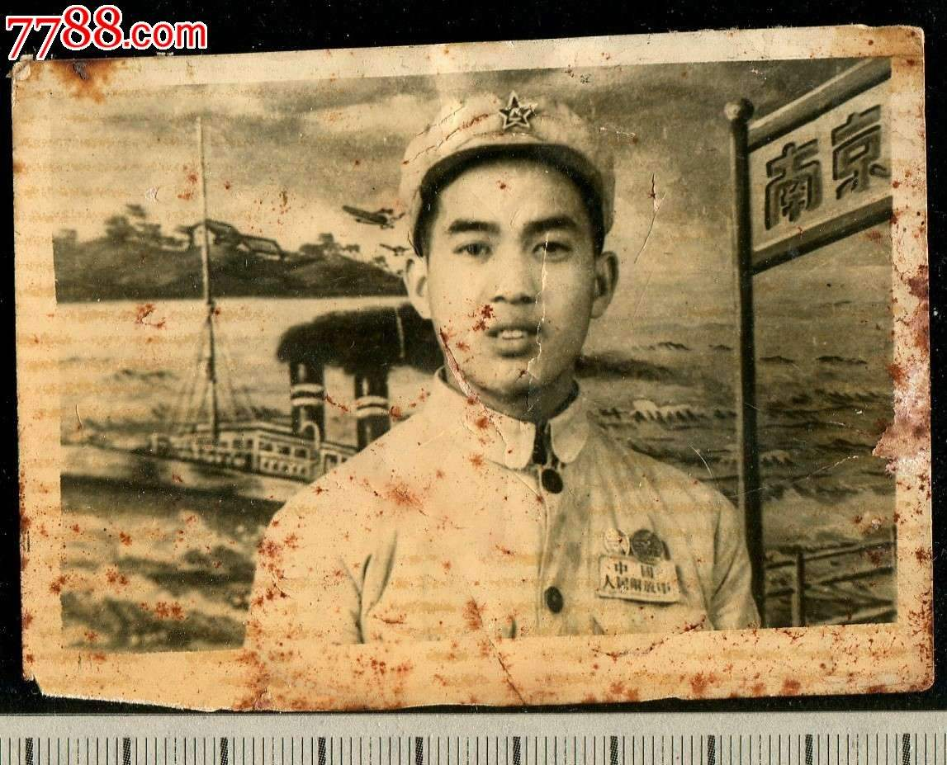?

Source: http://www.997788.com/pr/detail_auction_191_12087589.html

**Defining the problem:**

Sun Guoying(the client) is a government officer in Beijing, has a habit of taking and keeping pictures. However, some of her pictures where took many years ago and some of them have either faded or creased, and the digital copy is nowhere to be found. Moreover, she told me that sometimes she would spoil ink onto the pictures. Therefore she hoped that I could restore these pictures into their original color, fix the cracks on the pictures and have a digital version of the restored picture so that she will keep it on her computer. After some investigation, Mrs. Sun believes that my program should be able to accomplish two things: 1: restore the original color of the pictures 2: fix the cracks and stains (if any) on the pictures so that they look as good as new.

After the discussion with my project advisor Mrs. Wudi, my computer science teacher, I decided to use java to design a phone app for Mrs. Sun to meet her requirements

**Stating success criteria:**

· Allow the client download app on the phone(either Android or IOS)

· Use the phone to scan the picture

· Produce and store a new processed image on the phone

·No cracks and stains should be on the processed picture

·the color should be as realistic as the way it was taken real time.

**Rationale for the proposed product:**

Programming language is uniquely able to satisfy the needs of my client, since it the project requires complex data manipulation. Furthermore, phone app is better to meet the requirements of the user, because the user could scan the picture right away on their phone, without having to use any complex machines. Secondly, I use java as my programming language, for the reason that

• I use java is for its wide compatibility in different run-time environments,

• With ease of other source packages of image processing like Opencv.

* I have a considerable familiarity with java
* It is free and requires no licensing